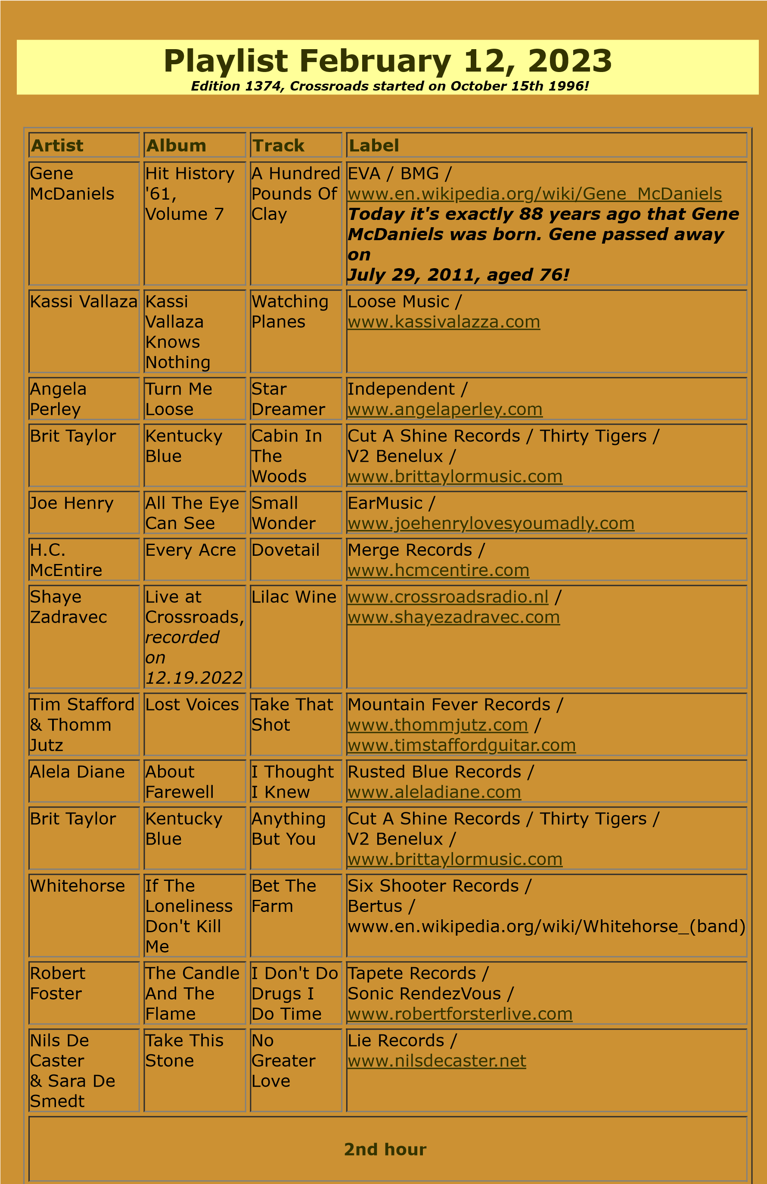

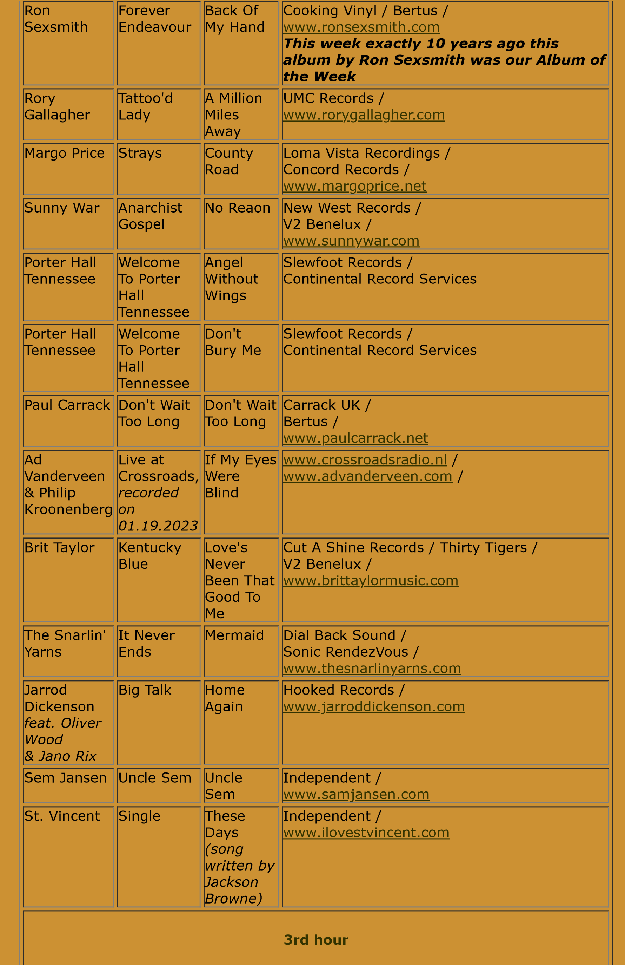

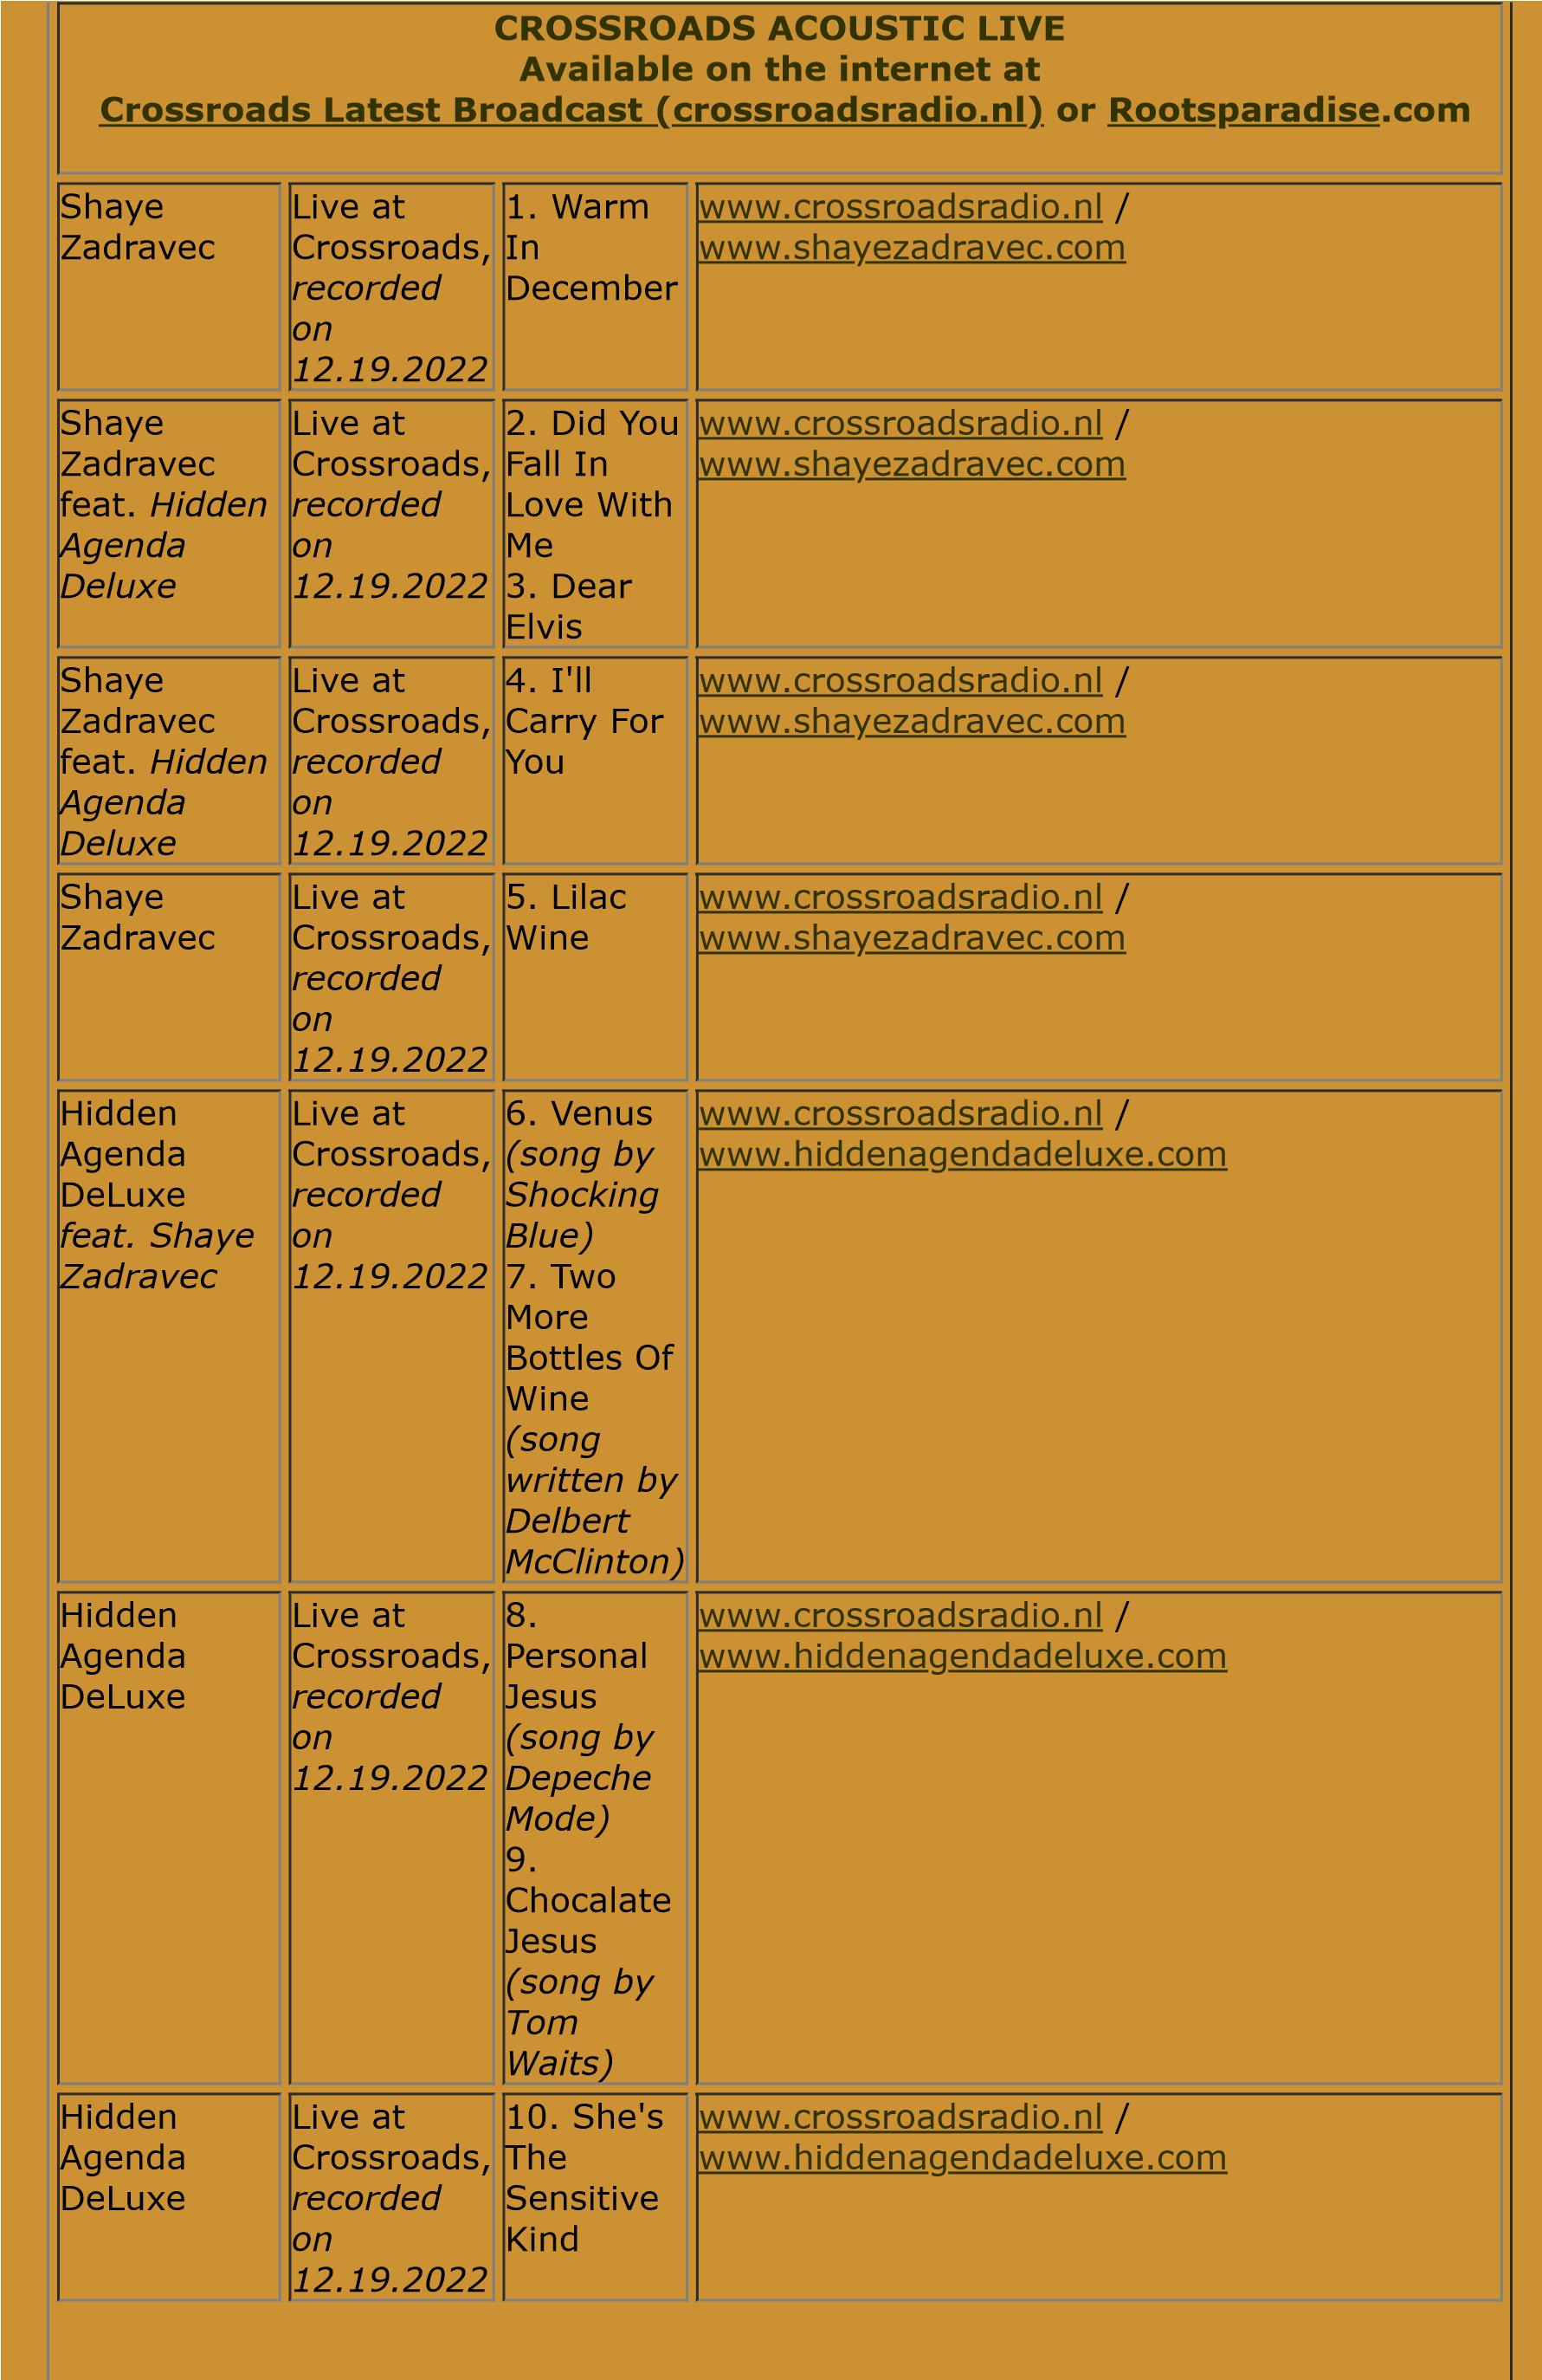

Hidden

Agenda

DeLuxe

*feat. Shaye*

*Zadravec*

Live at

Crossroads,

*recorded*

*on*

*12.19.2022*

11

. Better

Days

12.

Snowin'

On Raton

[www.crossroadsradio.n](http://www.crossroadsradio.nl/)

[l](http://www.crossroadsradio.nl/)

/

[m](http://www.hiddenagendadeluxe.com/)

[endadeluxe.co](http://www.hiddenagendadeluxe.com/)

[www.hiddenag](http://www.hiddenagendadeluxe.com/)

Hidden

Agenda

DeLuxe

Live at

Crossroads,

*recorded*

*on*

*12.19.2022*

13

. Long

Time

Gone

14

. What

A

Wonderful

World

[l](http://www.crossroadsradio.nl/)

[www.crossroadsradio.n](http://www.crossroadsradio.nl/)

/

[m](http://www.hiddenagendadeluxe.com/)

[endadeluxe.co](http://www.hiddenagendadeluxe.com/)

[www.hiddenag](http://www.hiddenagendadeluxe.com/)

Crossroads Radio

Jos van den Boom

Zuidzijde Haven 55

4611 HC Bergen op Zoom

The Netherlands

[www.crossroadsradio.n](http://www.crossroadsradio.nl/)

[l](http://www.crossroadsradio.nl/)

[www.roots](http://www.rootsparadise.com/)

[paradise.co](http://www.rootsparadise.com/)

[m](http://www.rootsparadise.com/)

[www.crossroadssessies.n](http://www.crossroadssessies.nl/)

[l](http://www.crossroadssessies.nl/)

\