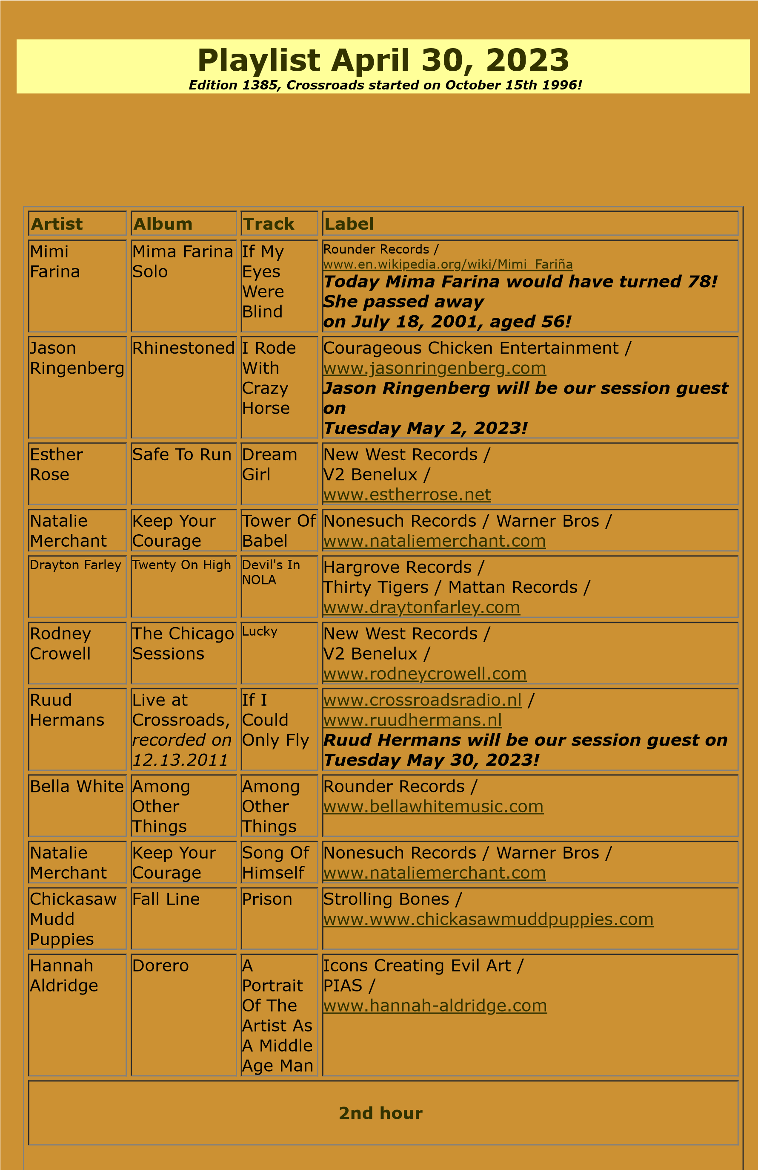

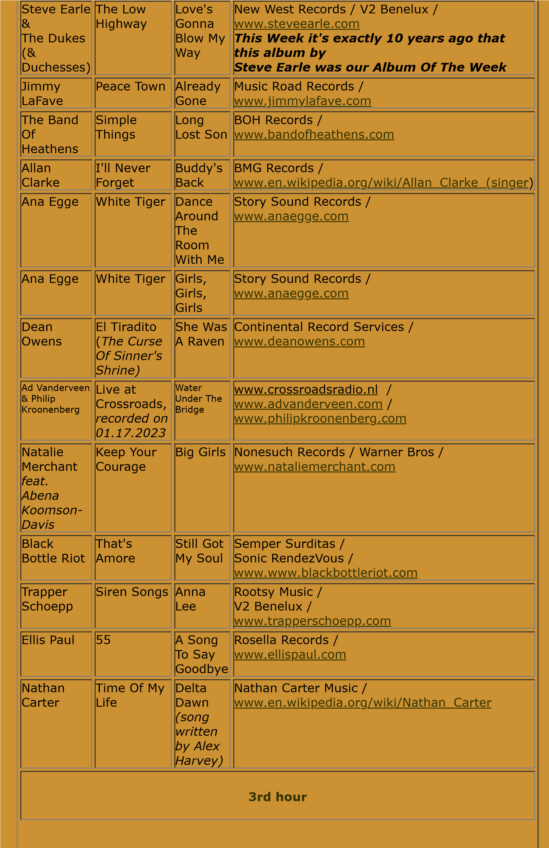

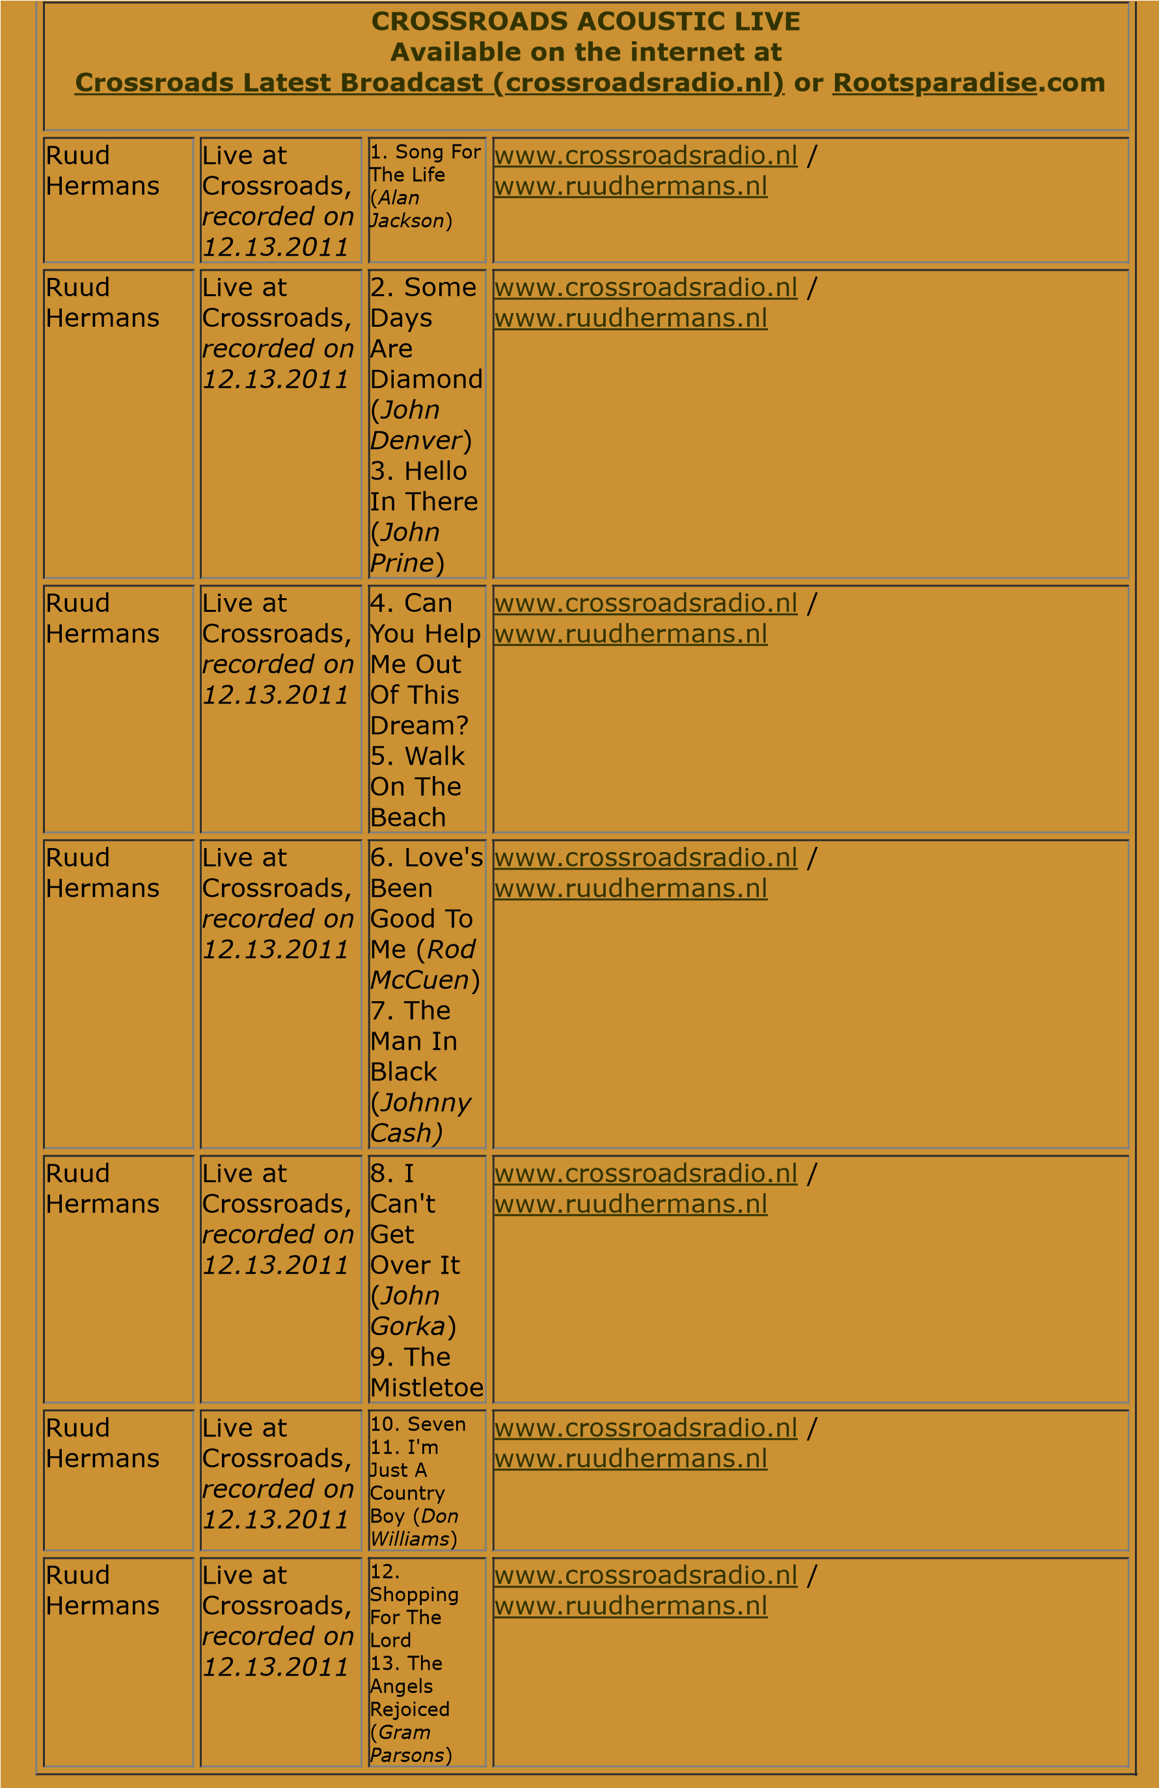

|  |  |
| --- | --- |
| |  | | --- | | Crossroads Radio  Jos van den Boom  Zuidzijde Haven 55  4611 HC Bergen op Zoom  The Netherlands [www.crossroadsradio.nl](http://www.crossroadsradio.nl/)  [www.rootsparadise.com](http://www.rootsparadise.com/) [www.crossroadssessies.nl](http://www.crossroadssessies.nl/) | |

\