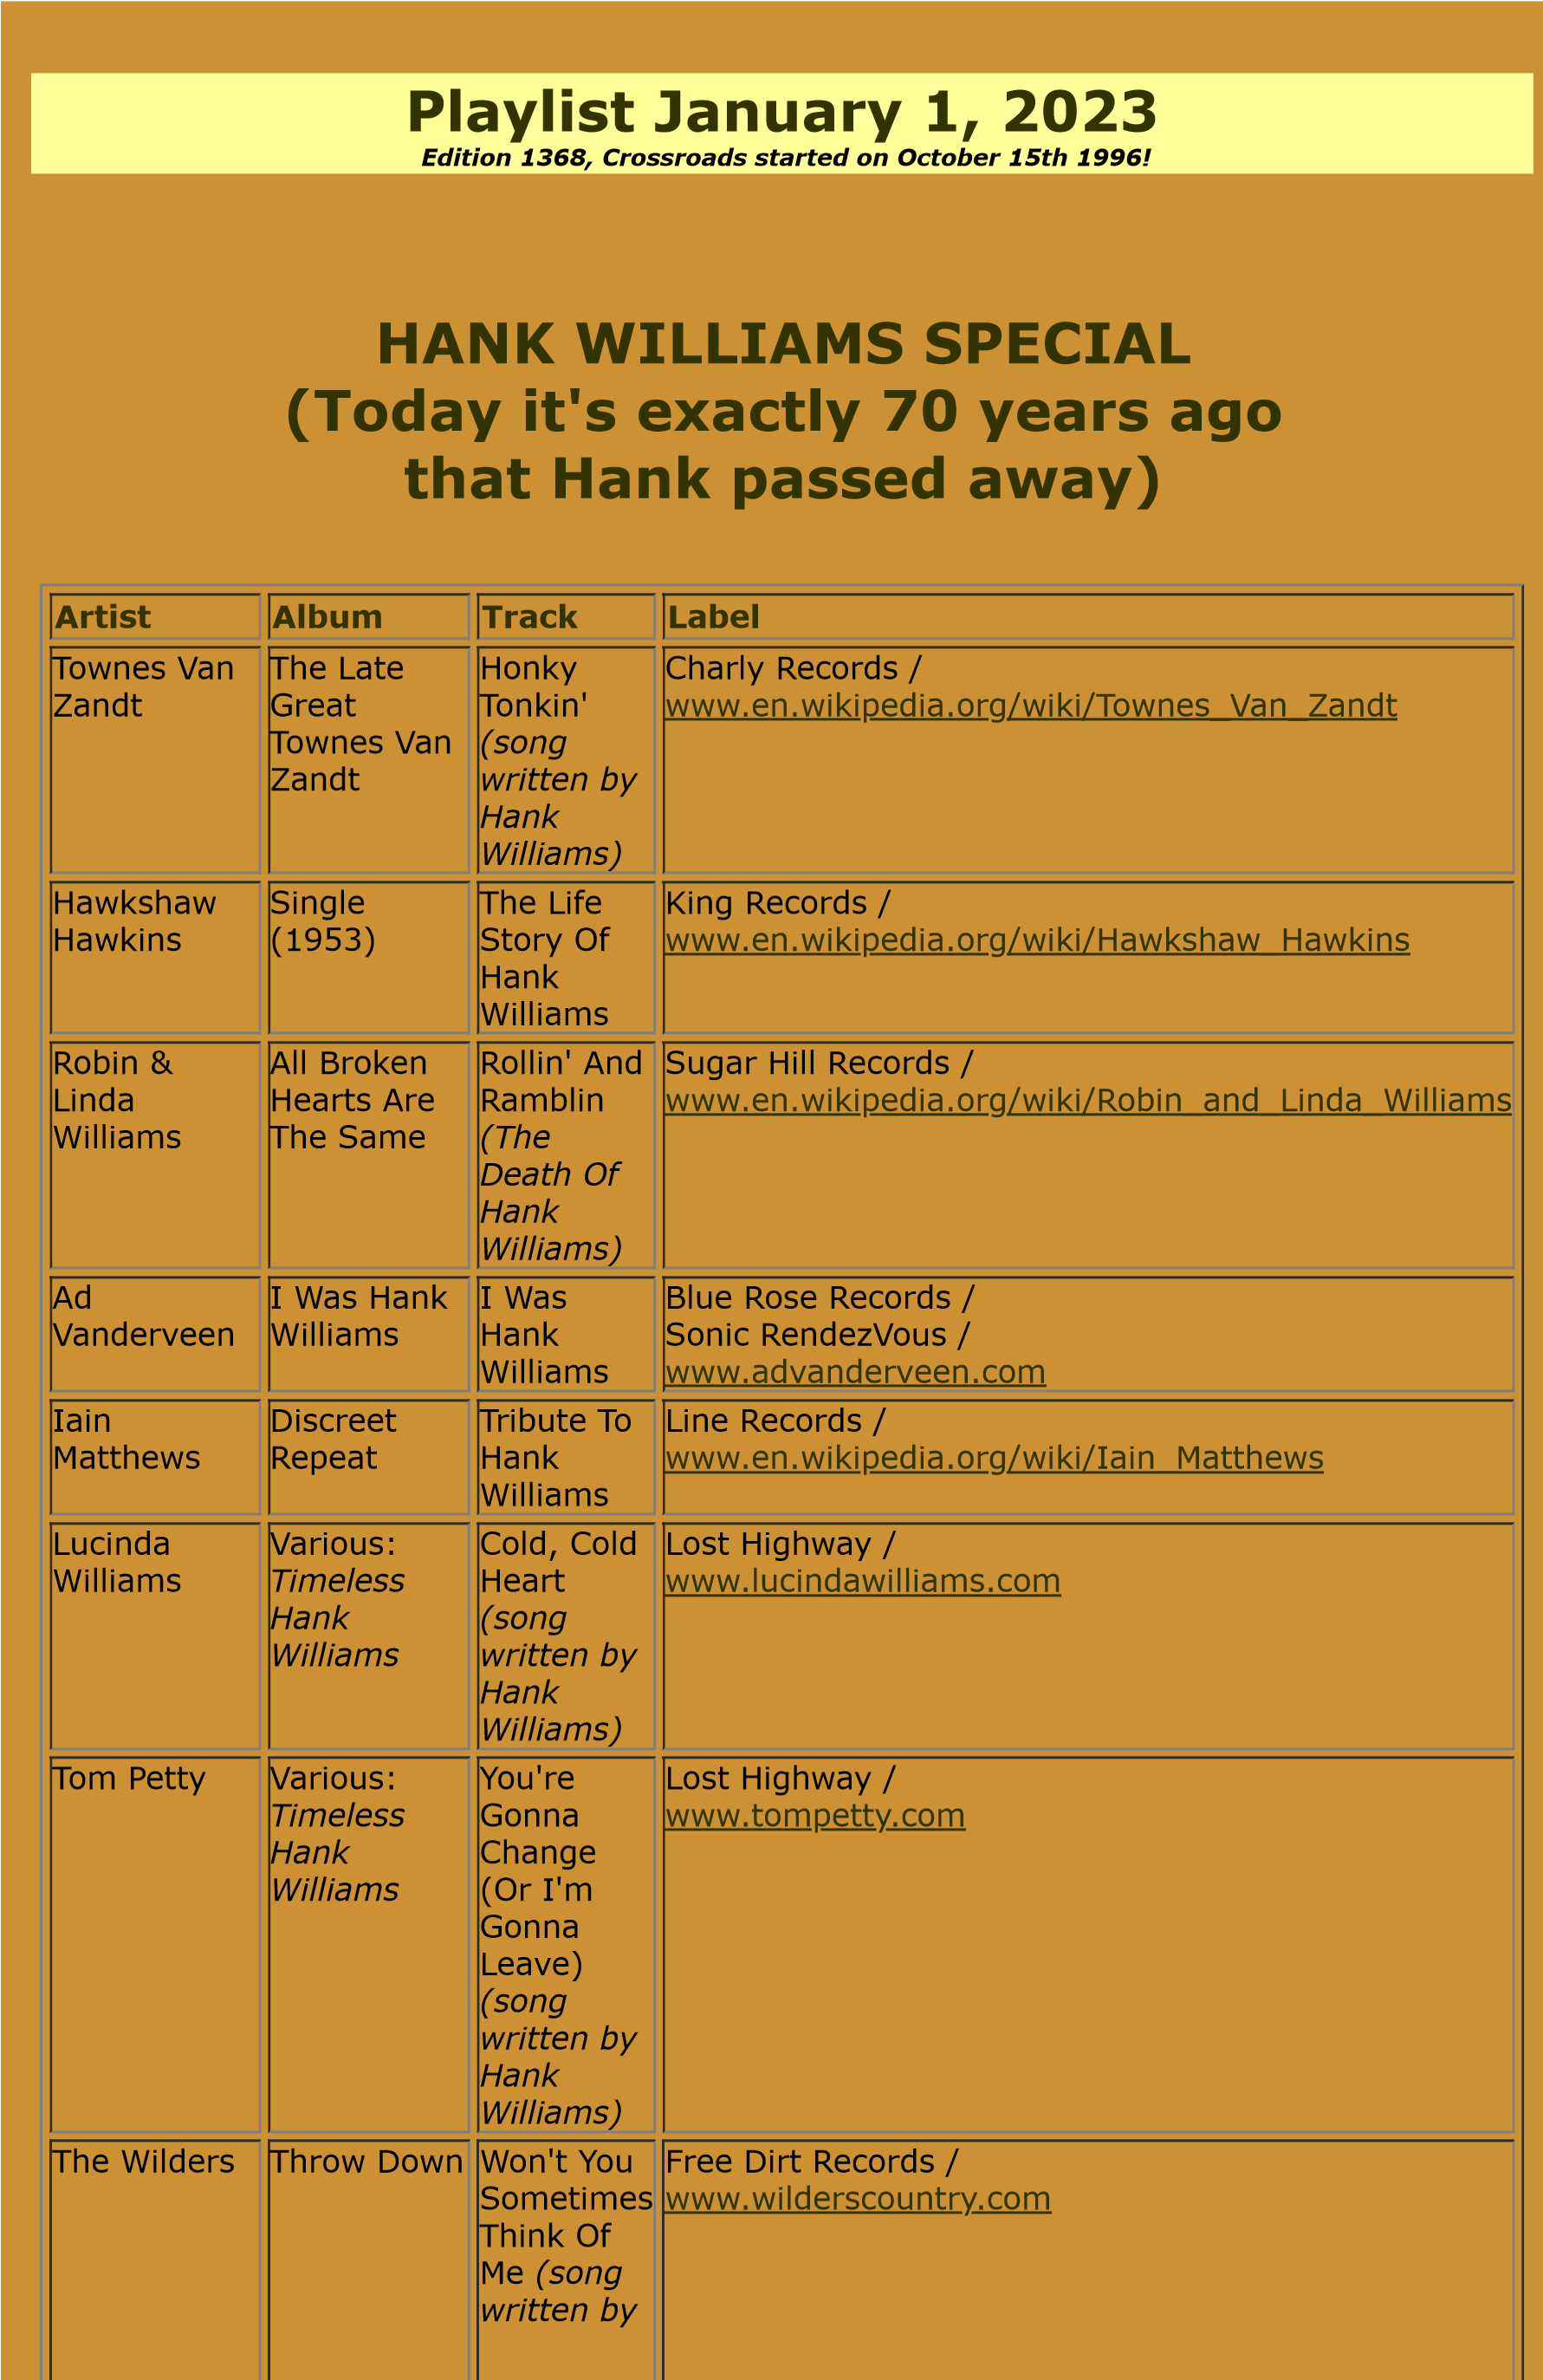

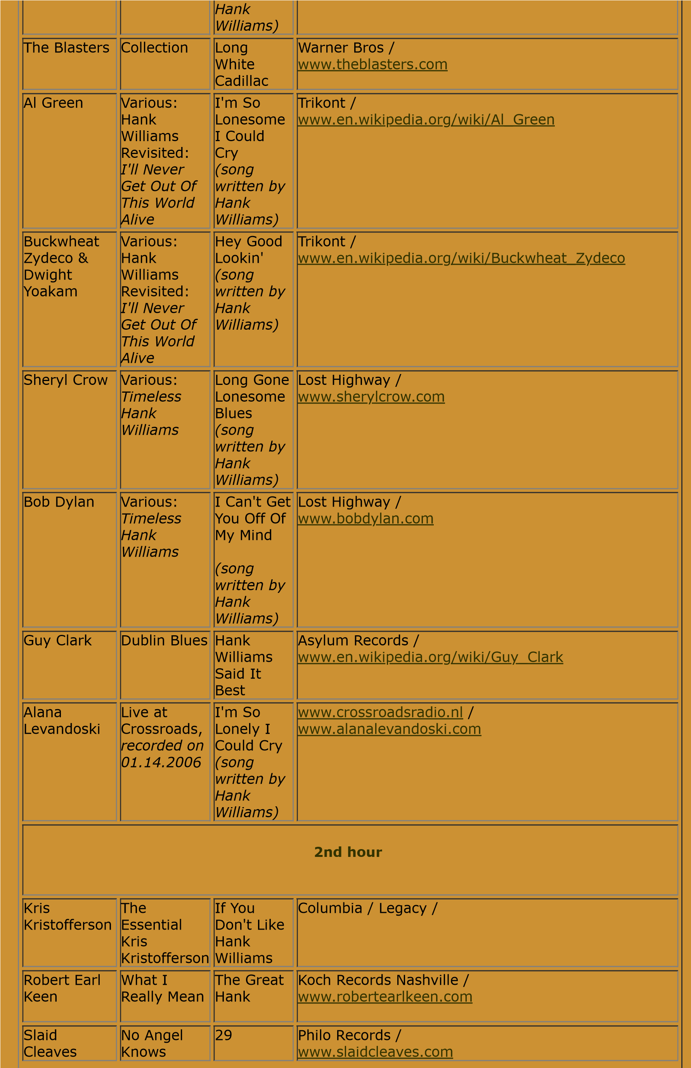

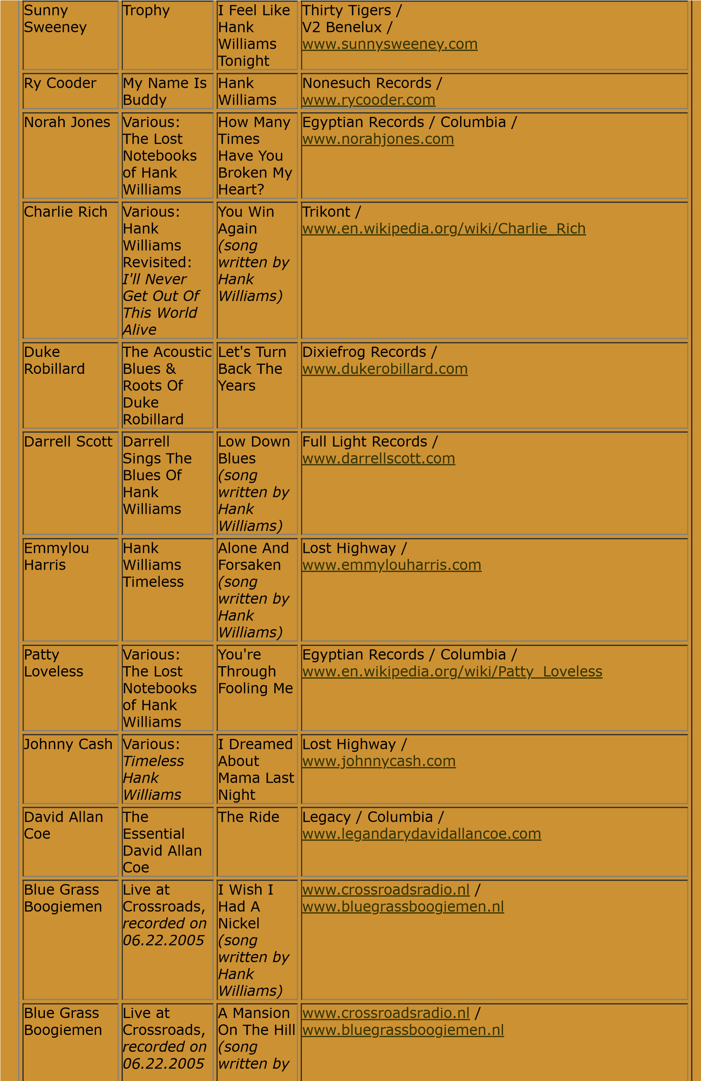

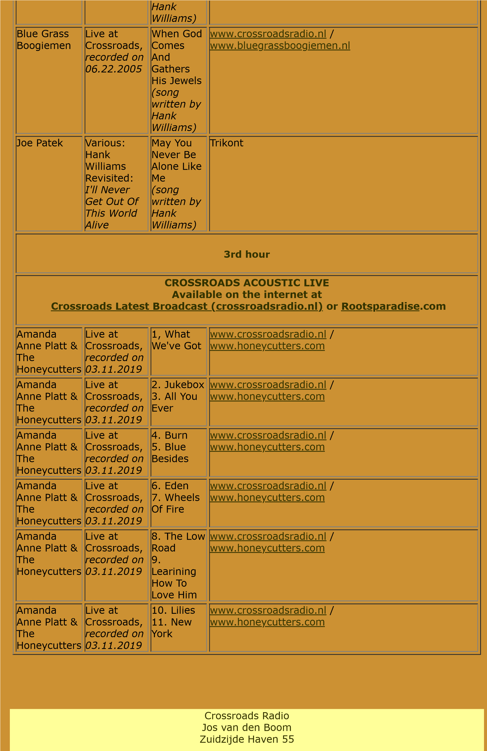

|  |  |
| --- | --- |
|  | 4611 HC Bergen op Zoom  The Netherlands [www.crossroadsradio.nl](http://www.crossroadsradio.nl/)  [www.rootsparadise.com](http://www.rootsparadise.com/) [www.crossroadssessies.nl](http://www.crossroadssessies.nl/) |
|  |

\