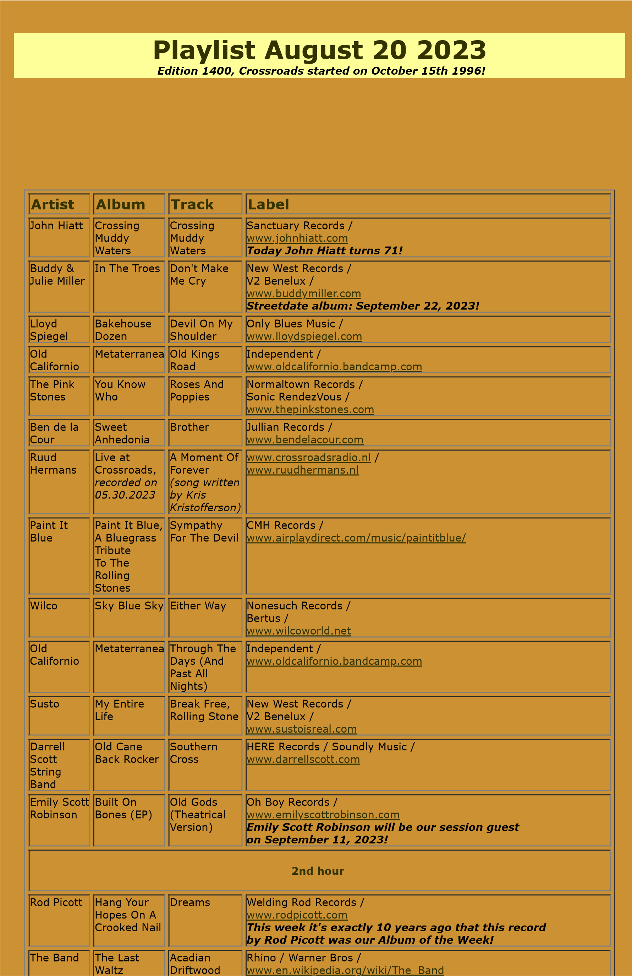

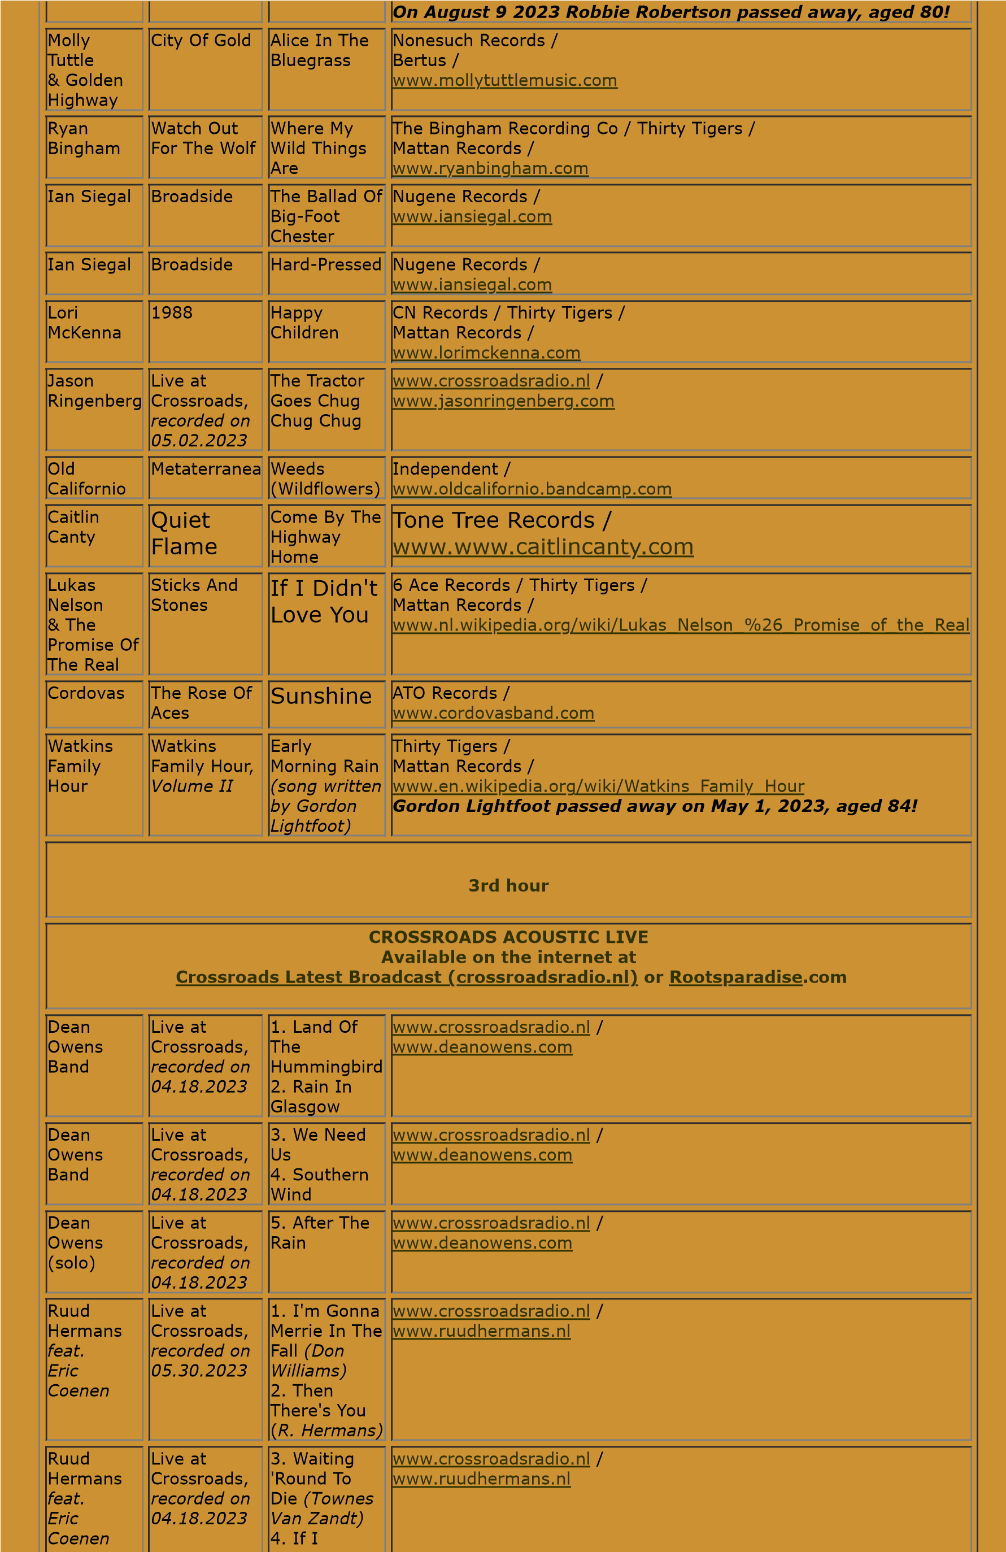

Needed You

*(*

*Townes Van*

*Zandt)*

Ruud

Hermans

*feat.*

*Eric*

*Coenen*

Live at

Crossroads,

*recorded on*

*04.18.2023*

5

. Blue

Horizon

*R.Hermans*

*(*

*& Hugh*

*Moffatt)*

[www.crossroadsradio.n](http://www.crossroadsradio.nl/)

[l](http://www.crossroadsradio.nl/)

/

[l](http://www.ruudhermans.nl/)

[www.ruudhermans.n](http://www.ruudhermans.nl/)

Crossroads Radio

Jos van den Boom

Zuidzijde Haven 55

4611 HC Bergen op Zoom

The Netherlands

[www.crossroadsradio.n](http://www.crossroadsradio.nl/)

[l](http://www.crossroadsradio.nl/)

[www.roots](http://www.rootsparadise.com/)

[paradise.co](http://www.rootsparadise.com/)

[m](http://www.rootsparadise.com/)

[www.crossroadssessies.n](http://www.crossroadssessies.nl/)

[l](http://www.crossroadssessies.nl/)

\