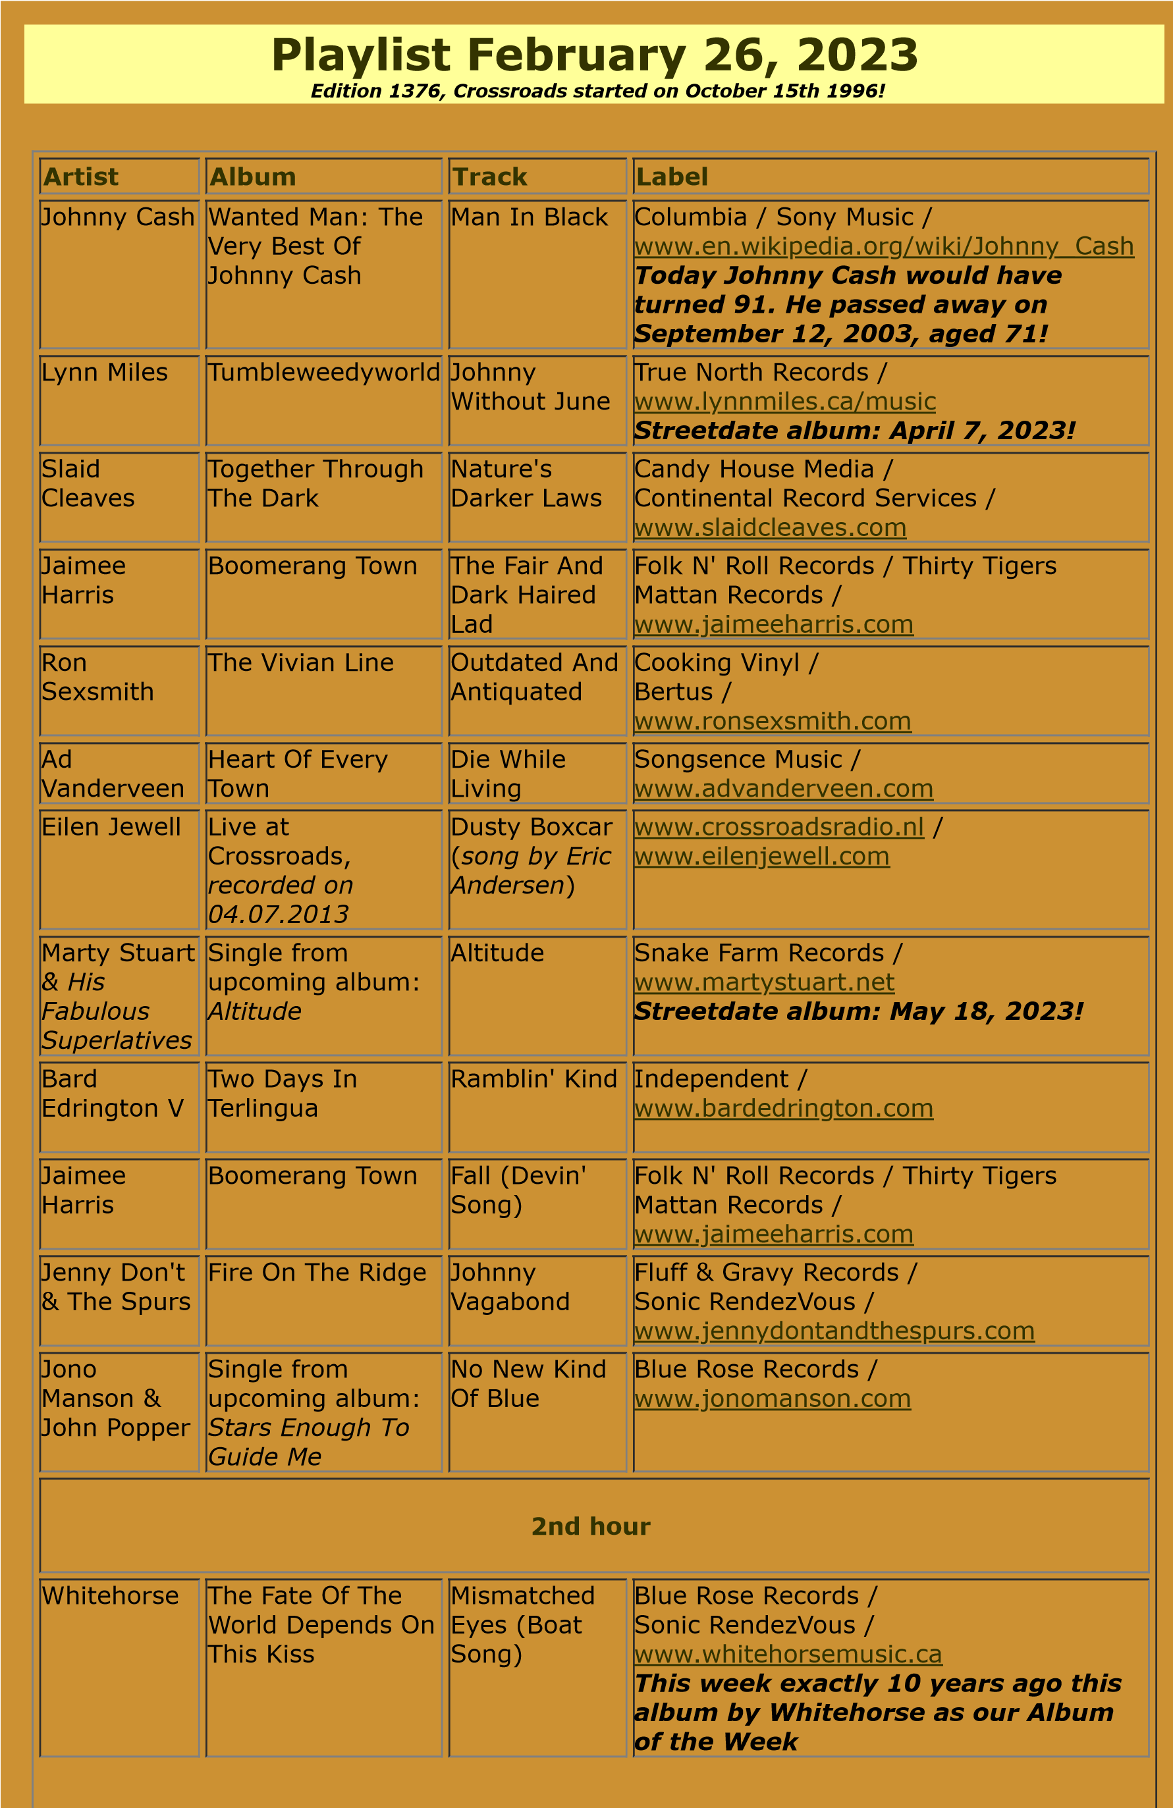

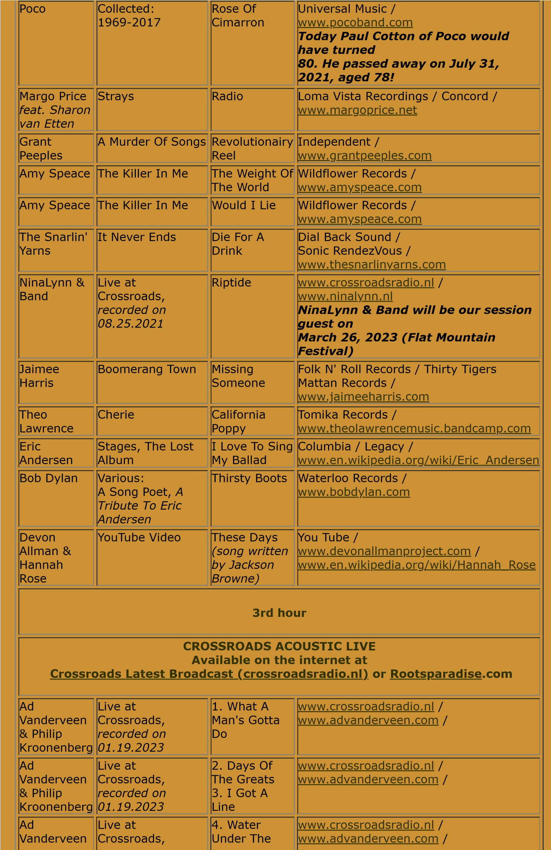

& Philip

Kroonenberg

*recorded on*

*01.19.2023*

Bridge

. Some More

5

Time

Ad

Vanderveen

& Philip

Kroonenberg

Live at

Crossroads,

*recorded on*

*01.19.2023*

6

. Mystery

7

. Yellow

Light

[www.crossroadsradio.n](http://www.crossroadsradio.nl/)

[l](http://www.crossroadsradio.nl/)

/

[www.advanderveen.co](http://www.advanderveen.com/)

[m](http://www.advanderveen.com/)

/

Ad

Vanderveen

& Philip

Kroonenberg

Live at

Crossroads,

*recorded on*

*01.19.2023*

. If My Eyes

8

Were Blind

[www.crossroadsradio.n](http://www.crossroadsradio.nl/)

[l](http://www.crossroadsradio.nl/)

/

[www.advanderveen.co](http://www.advanderveen.com/)

[m](http://www.advanderveen.com/)

/

Ad

Vanderveen

Heart Of Every

Town

. Child Again

1

2

. Never

Growing Old

Songsence Music /

[www.advanderveen.co](http://www.advanderveen.com/)

[m](http://www.advanderveen.com/)

Crossroads Radio

Jos van den Boom

Zuidzijde Haven 55

4611 HC Bergen op Zoom

The Netherlands

[www.crossroadsradio.n](http://www.crossroadsradio.nl/)

[l](http://www.crossroadsradio.nl/)

[www.roots](http://www.rootsparadise.com/)

[paradise.co](http://www.rootsparadise.com/)

[m](http://www.rootsparadise.com/)

[www.crossroadssessies.n](http://www.crossroadssessies.nl/)

[l](http://www.crossroadssessies.nl/)

\