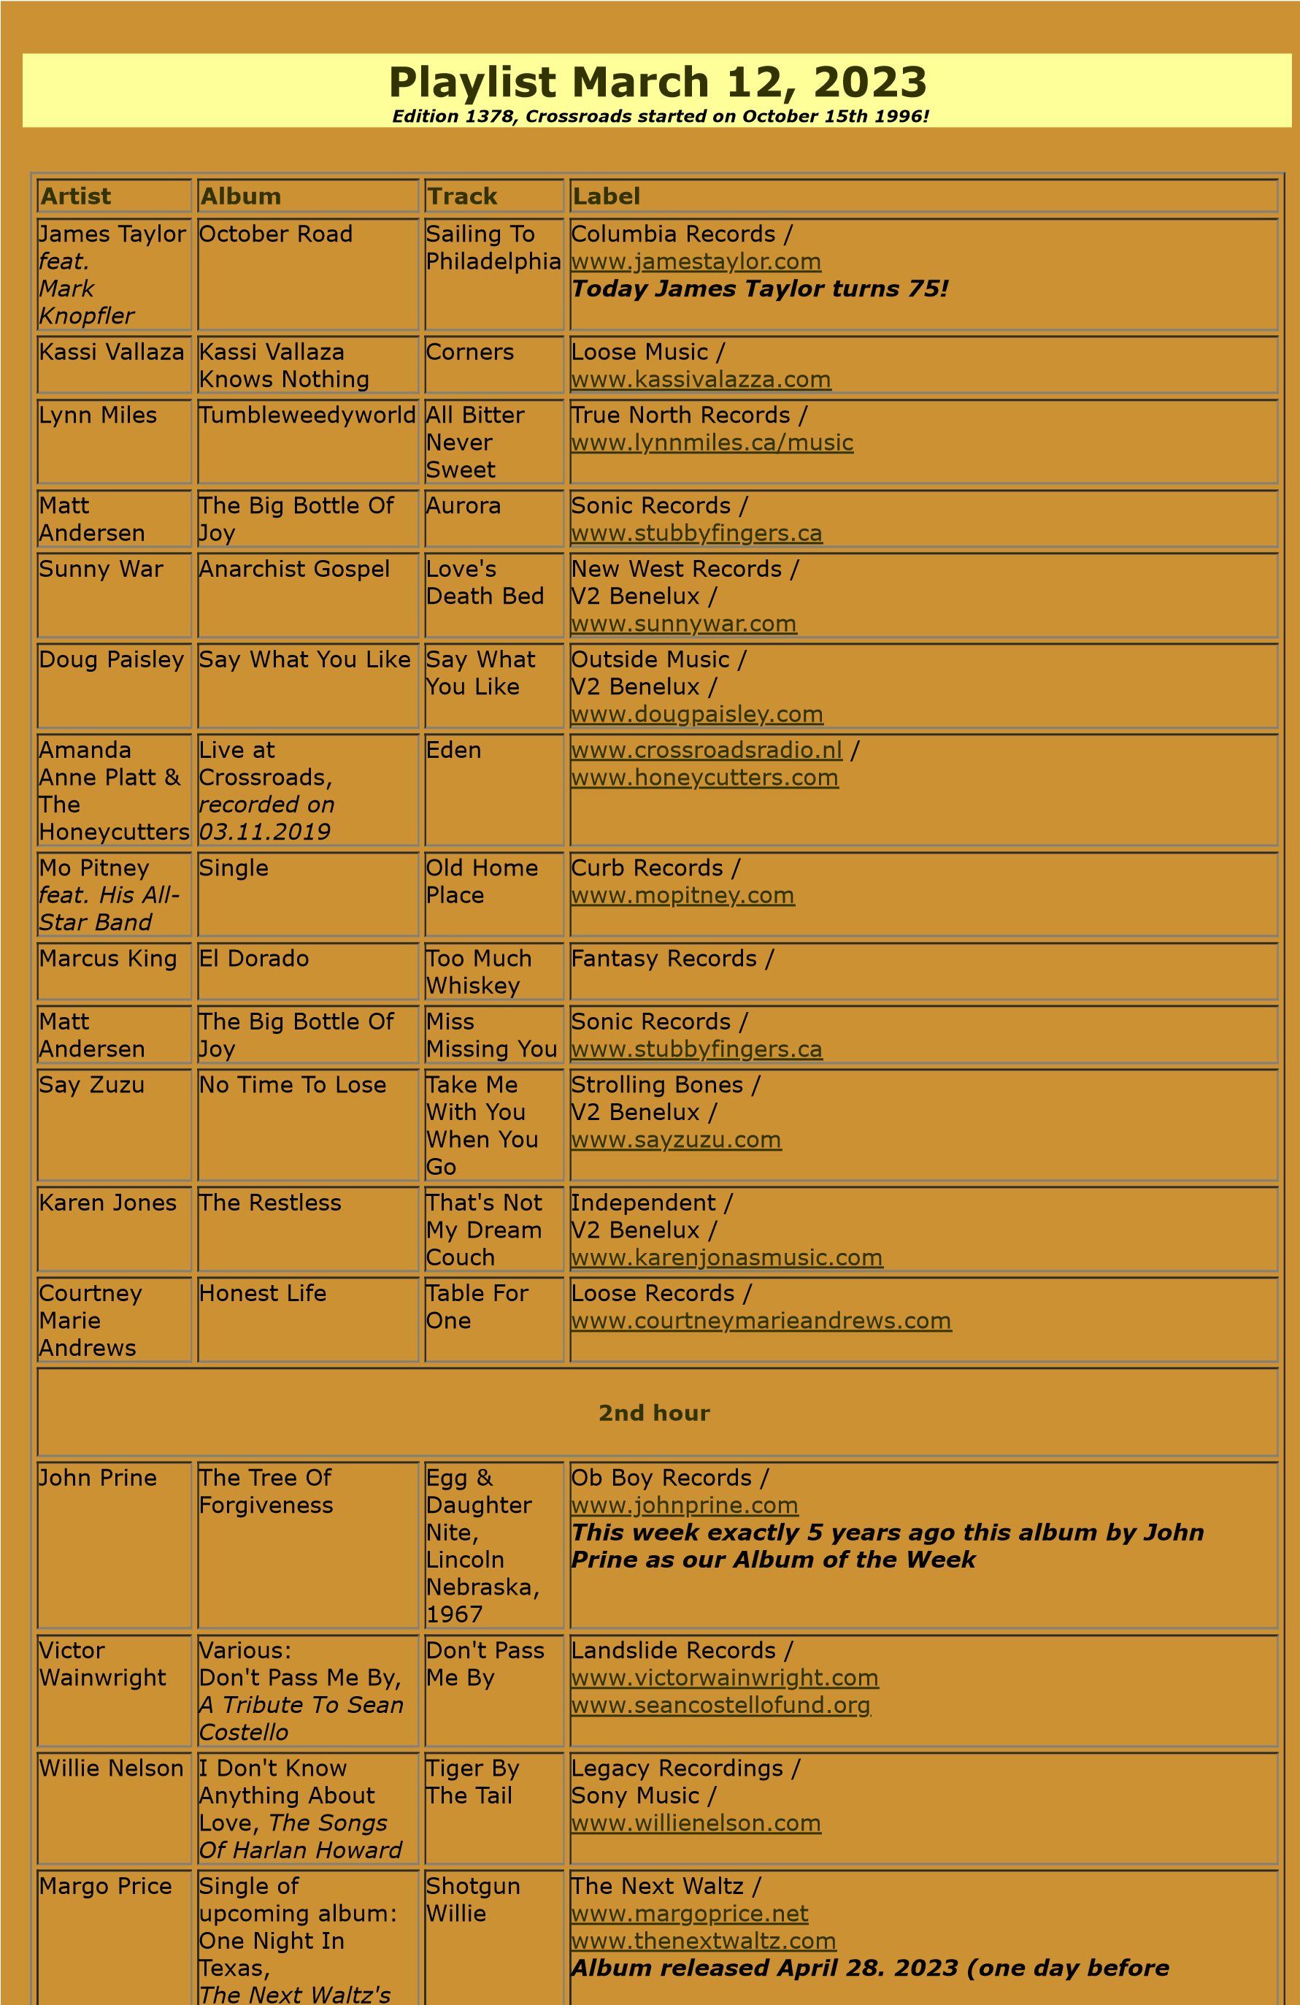

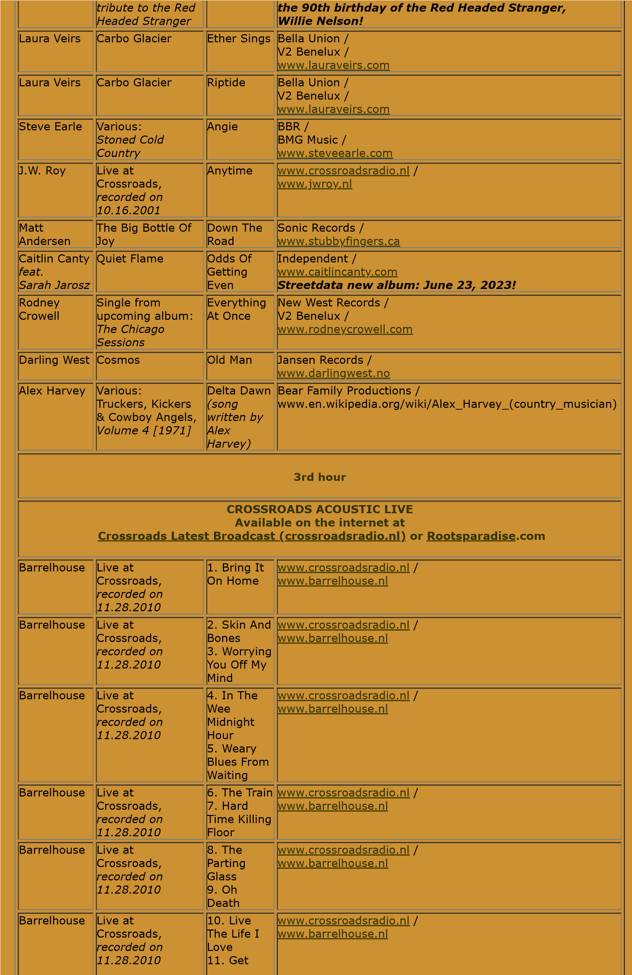

Like You

Used To Be

Barrelhouse

Live at

Crossroads,

*recorded on*

*11.28.2010*

. Last

12

Night I Lost

The Best

Friend I've

Ever Had

[www.crossroadsradio.n](http://www.crossroadsradio.nl/)

[l](http://www.crossroadsradio.nl/)

/

[www.barrelhouse.n](http://www.barrelhouse.nl/)

[l](http://www.barrelhouse.nl/)

Crossroads Radio

Jos van den Boom

Zuidzijde Haven 55

4611 HC Bergen op Zoom

The Netherlands

[www.crossroadsradio.n](http://www.crossroadsradio.nl/)

[l](http://www.crossroadsradio.nl/)

[www.roots](http://www.rootsparadise.com/)

[paradise.co](http://www.rootsparadise.com/)

[m](http://www.rootsparadise.com/)

[www.crossroadssessies.n](http://www.crossroadssessies.nl/)

[l](http://www.crossroadssessies.nl/)

\