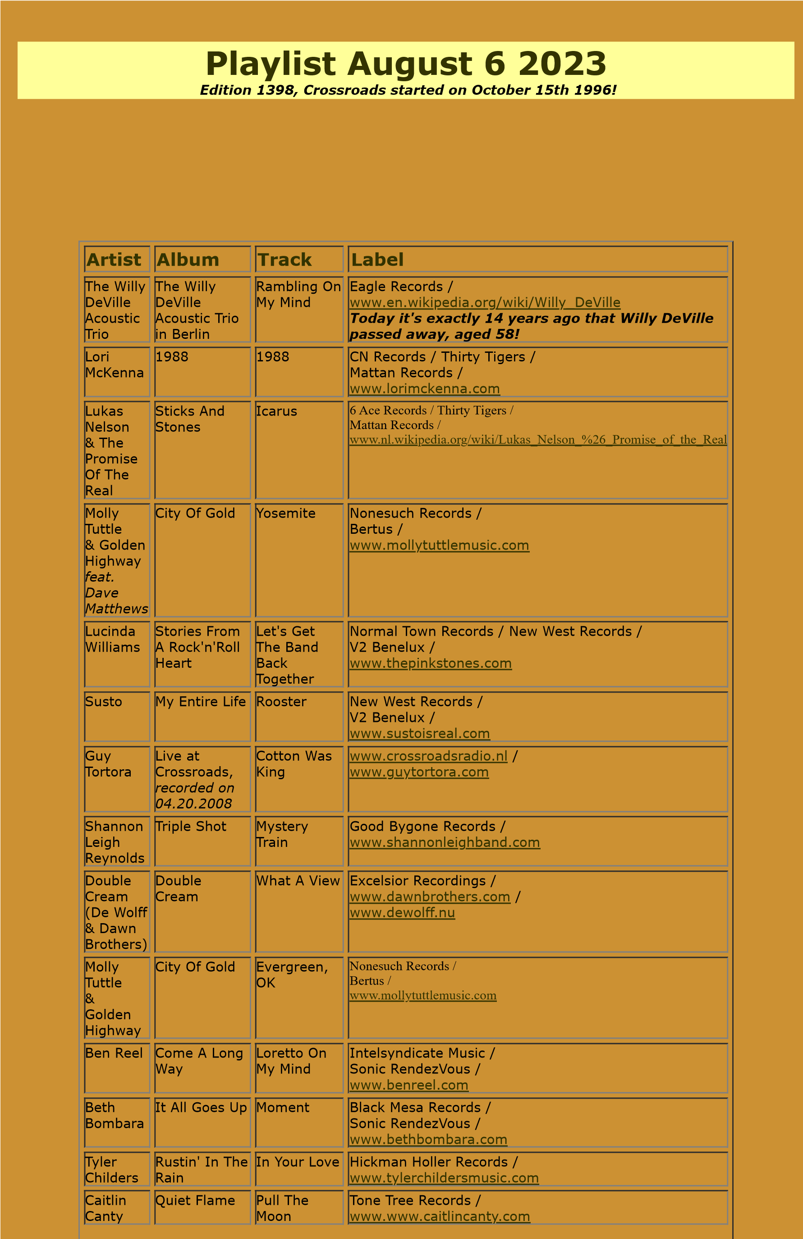

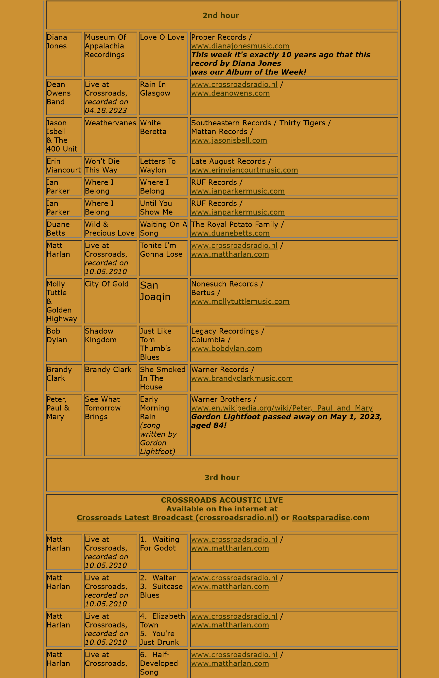

*recorded on*

*10.05.2010*

7

. Warm

November

Matt

Harlan

Live at

Crossroads,

*recorded on*

*10.05.2010*

8

. Tips &

Compliments

9

. Dresses

[www.crossroadsradio.n](http://www.crossroadsradio.nl/)

[l](http://www.crossroadsradio.nl/)

/

[www.mattharlan.co](http://www.mattharlan.com/)

[m](http://www.mattharlan.com/)

Matt

Harlan

Live at

Crossroads,

*recorded on*

*10.05.2010*

10

. Too

Much Going

On

. Driving

11

Song

[www.crossroadsradio.n](http://www.crossroadsradio.nl/)

[l](http://www.crossroadsradio.nl/)

/

[www.mattharlan.co](http://www.mattharlan.com/)

[m](http://www.mattharlan.com/)

Crossroads Radio

Jos van den Boom

Zuidzijde Haven 55

4611 HC Bergen op Zoom

The Netherlands

[www.crossroadsradio.n](http://www.crossroadsradio.nl/)

[l](http://www.crossroadsradio.nl/)

[www.roots](http://www.rootsparadise.com/)

[paradise.co](http://www.rootsparadise.com/)

[m](http://www.rootsparadise.com/)

[www.crossroadssessies.n](http://www.crossroadssessies.nl/)

[l](http://www.crossroadssessies.nl/)

\