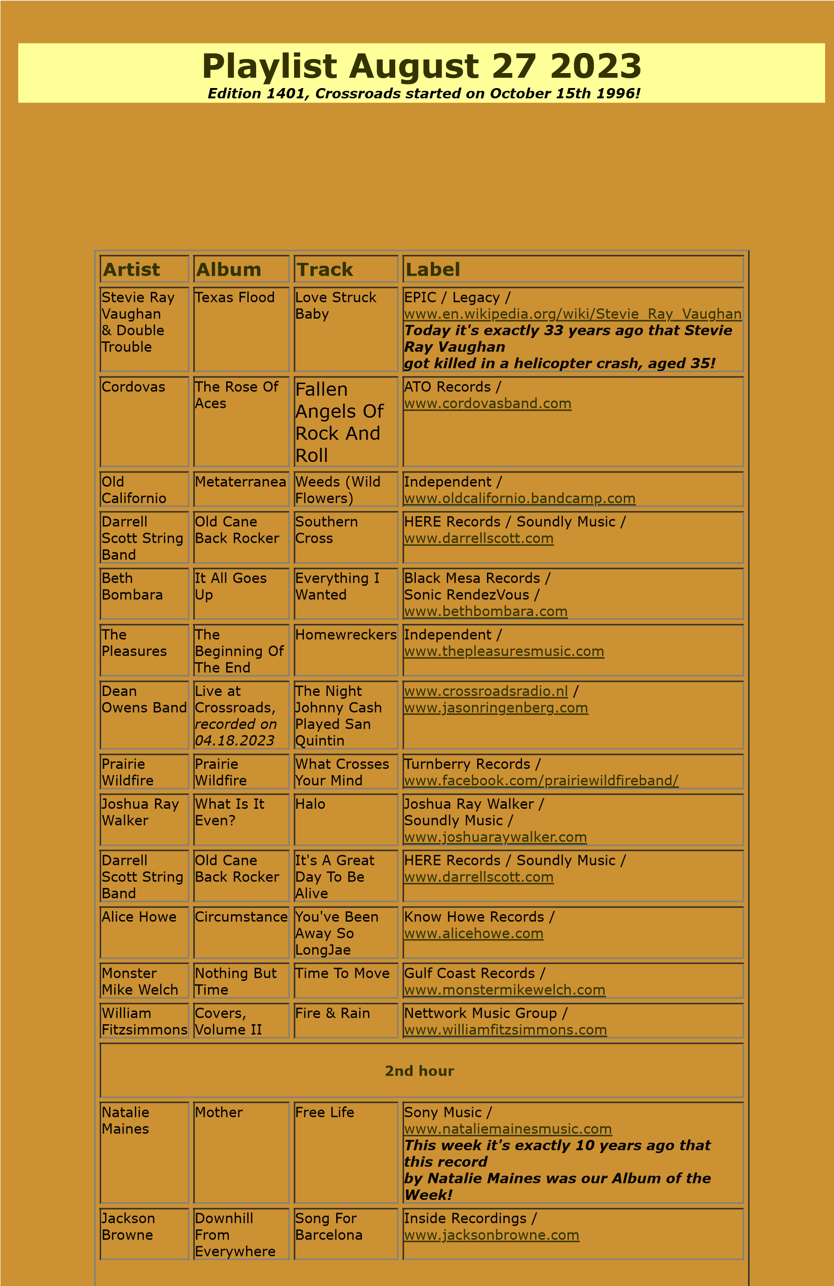

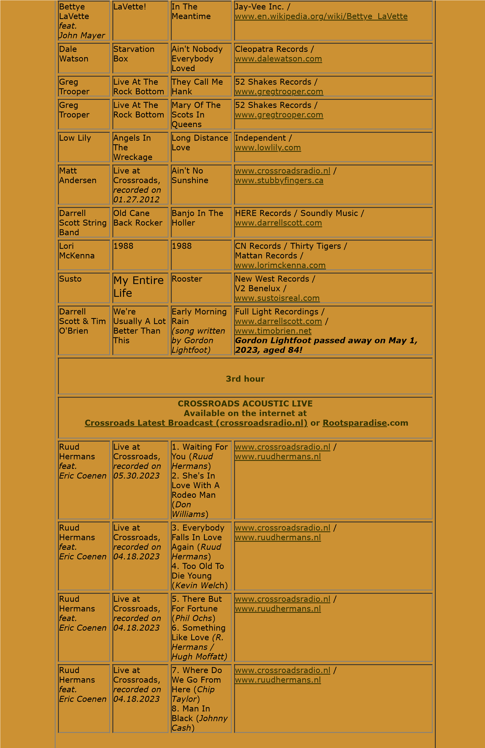

Ruud

Hermans

*feat.*

*Eric Coenen*

Live at

Crossroads,

*recorded on*

*04.18.2023*

9

. Green

Green Grass

Of Home

(

*Curly*

*Putman*

)

10

. If I Could

Only Fly

(

*Blaze Foley*

)

[www.crossroadsradio.n](http://www.crossroadsradio.nl/)

[l](http://www.crossroadsradio.nl/)

/

[www.ruudhermans.n](http://www.ruudhermans.nl/)

[l](http://www.ruudhermans.nl/)

Ruud

Hermans

*feat.*

*Eric Coenen*

Live at

Crossroads,

*recorded on*

*04.18.2023*

11

. Take Me

Home.

Country Road

(

*John Denver*

)

[www.crossroadsradio.n](http://www.crossroadsradio.nl/)

[l](http://www.crossroadsradio.nl/)

/

[l](http://www.ruudhermans.nl/)

[www.ruudhermans.n](http://www.ruudhermans.nl/)

Crossroads Radio

Jos van den Boom

Zuidzijde Haven 55

4611 HC Bergen op Zoom

The Netherlands

[www.crossroadsradio.n](http://www.crossroadsradio.nl/)

[l](http://www.crossroadsradio.nl/)

[www.roots](http://www.rootsparadise.com/)

[paradise.co](http://www.rootsparadise.com/)

[m](http://www.rootsparadise.com/)

[www.crossroadssessies.n](http://www.crossroadssessies.nl/)

[l](http://www.crossroadssessies.nl/)

\